CSE 219 — Signals and Linear Systems
Lec 5 · Sampling, Aliasing and Reconstruction
Lesson notes · Exam approach · TF practice with solutions · Quick notes (Ashraf Sir's portion)

How to Read These Notes
EXAM FOCUS | Exam importance, where it appears in the TF collection
MEMORIZE | Rules, tables and formulas to memorize
TRAP | Common mistakes and exam traps
EXAM-READY ANSWER | Model wording you can write in the exam
NOTE | Extra explanation / clarification
Grey box, monospace | Code, worked tables, derivations and hand-drawn sketches
Centered grey box | Formula to remember / final numerical result
Purple heading / ✔ green | Practice questions / their solutions

Contents
Exam Map — What the TF Papers Ask — sampling questions and their weight
Lesson 9 — Impulse-Train Sampling and the Spectrum of the Sampled Signal — Xp = (1/T)ΣX(j(ω − kωs)), P(jω), duality, FT of impulse trains
Lesson 10 — The Sampling Theorem and Aliasing — ωs > 2ωM, proof, oversampling vs aliasing, natural sampling
Lesson 11 — Ideal Reconstruction, ZOH and Linear Interpolation — sinc interpolation, h0, h1, comparison, real-time DAC
Lesson 12 — Practical Issues; Connection to the DFT — time-limited ⇒ not band-limited, anti-alias filter, periodic signals
Quick Notes — Sampling — merged revision notes + key diagrams
NOTE Slide numbers are PDF page numbers of Lecture 5 - Sampling.pdf (47 pages, “Lec 5”); the printed slide number is one less. Natural sampling and discrete-time down-sampling (CSE 219 2022-23 Q4(b)) are textbook background (marked).

Exam Map — What the TF Papers Ask
Session (paper) | Questions answered by this note
2023-24 (CSE 219) | Q5(c) Compare ideal (sinc), ZOH, linear interpolation; choose for a real-time DAC (10) · Q7(c) Nyquist–Shannon theorem; X_p(jω) satisfying/violating; why aliasing is irrecoverable (10)
2022-23 (CSE 219) | Q1(c) Band-limited x(t), ω_s > 2ω_M: show x(t) is uniquely determined by x(nT) (15) · Q4(b) X(e^{jω}) = 0 for 2π/9 ≤ |ω| ≤ π: lowest rate at which x[n] can be sampled (decimated) (10)
2021-22 (CSE 311) | Q3(b) Nyquist-rate samples all zero except g(0) = A: find g(t) (15)
2020-21 (CSE 311) | Q1(b) Can past samples foretell the future of a band-limited signal? (10) · Q3(a) Why practical signals can't be fully recovered; aliasing; how to minimise (24)
2019-20 (EEE 211) | Q7(b) x = sin(ω_Bt/2)/(πt) × Σδ(t−nπ/ω_B) → h = sin(3ω_Bt/2)/(πt): y(t) (20) · Q8(a) FT of an impulse train is an impulse train (15)
2019-20 (CSE 311) | Q3 FT of 2B sinc(2πBt) / B sinc²(πBt); spectrum when sampled at 1.5× Nyquist; general sampled spectrum (35)
2018-19 (EEE 211) | Q3(a) FT of an impulse train is an impulse train; sketch both (10) · Q3(b) FT of sin1000πt + cos1200πt; sampling period for no aliasing (10)
2018-19 (CSE 311) | Q1(a) g(t) band-limited to 50 Hz, samples 0.01 s apart all 0 except g(0)=1: g(t), G(f); FT of δ (21) · Q3(b) Cause of aliasing, its problems, how compensated (20)
2017-18 (EEE 211) | Q2(c) Natural sampling with a rectangular pulse train: spectrum; recoverable? (15)
2016-17 (EEE 211) | Q6(c) x·p (impulse train nπ/ω_B) → h = sin(3ω_Bt/2)/(πt): spectra p, z, h, y (12)
2016-17 (CSE 311) | Q2(b) State & prove the sampling theorem; anti-alias filter; why sample above Nyquist (16)
2015-16 (EEE 301) | Q6(b) z = x·y (150 Hz, 350 Hz): max T_s; spectra for T_s = 0.5 ms, 2 ms (12)
2014-15 (EEE 301) | Q6(b) Natural sampling with rectangular pulses: spectrum; recoverable? (15)
2014-15 (CSE 311) | Q8(a) FT of an impulse-sampled signal; sampling theorem (15) · Q2(c) [L-3] Aliasing effect; how eliminated (10)
2013-14 (EEE 301) | Q8(a) Impulse sampling (T = 1/8 ms) of a 5 kHz signal, filter: P, X_s, Y; recoverable? (17)
2013-14 (CSE 311) | Q2(a) State and prove Nyquist's sampling theorem (13) · Q2(b) Practical issues in sampling and reconstruction; how handled (10)
2012-13 (EEE 301) | Q6(b) Sampler → h → squarer: X, P, Z, H, Y, S (15)
2012-13 (CSE 311) | Q8(a) Prove the minimum sampling frequency is 2B (15)
2011-12 (EEE 301) | Q2(b) Alternating-sign impulse train sampling: recovery system; X_p, Y (18)
2010-11 (EEE 301) | Q2(b) x = sin(ω_Bt/2)/(πt) × impulse train: X, P, X_s, h, H, Y (15)
2010-11 (CSE 311) | Q6(c) Samples at 2B through ideal LPF (bandwidth B) give an output ∝ f(t) (12)

EXAM FOCUS Sampling is asked in every paper: 'state and prove the sampling theorem' (CSE 311 2012-13, 2013-14, 2016-17; CSE 219 2022-23 Q1(c) 15 marks, 2023-24 Q7(c) 10), spectrum sketches of an impulse-sampled signal (EEE every year) and aliasing explanations. Know the one-line derivation Xp = (1/T)ΣX(j(ω − kωs)) and the sketch of non-overlapping vs overlapping copies.

Lesson 9 — Impulse-Train Sampling and the Spectrum of the Sampled Signal
Lec 5 sl. 4–17
Many signals give the same samples (sl. 5), so recovery needs a condition. Model sampling as multiplication by an impulse train (sl. 6):
x_p(t) = x(t)p(t) = Σ x(nT)δ(t − nT), p(t) = Σ δ(t − nT), ω_s = 2π/T

Two roads to X_p(jω) (sl. 8–17)
- Road 1 — transform the product: X_p(jω) = Σ x(nT)e^{−jωnT}: correct (it is the DTFT after ωT → ω) but X(jω) does not appear — uninterpretable.
- Road 2 — multiplication in time = convolution in frequency: X_p = (1/2π)X(jω) * P(jω). Needs P(jω).
Duality: x(t) ↔ X(jω) ⇒ X(jt) ↔ 2πx(−ω) (from x(t) = (1/2π)∫X e^{jωt}dω: 2πx(−t) = ∫X(jω)e^{−jωt}dω, rename)
Multiplication ↔ convolution: u(t)v(t) ↔ (1/2π)U * V (duality of the convolution property)
P(jω): p is T-periodic ⇒ Fourier series p = (1/T)Σ e^{jkω_s t} (c_k = (1/T)∫δ(t)e^{−jkω_s t}dt = 1/T);
e^{jkω_s t} ↔ 2πδ(ω − kω_s) ⇒ P(jω) = (2π/T)Σ δ(ω − kω_s) (an impulse train is an impulse train)
Convolving with δ(ω − kω_s) just shifts: X * δ(ω − kω_s) = X(j(ω − kω_s))

X_p(jω) = (1/2π) X(jω) * (2π/T)Σδ(ω − kω_s) = (1/T) Σ_{k=−∞}∞ X(j(ω − kω_s))
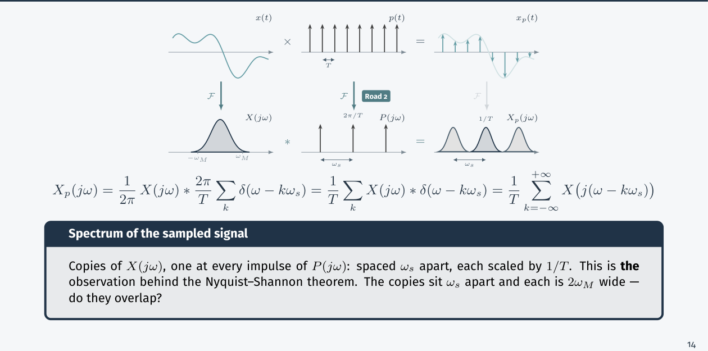
Figure 9.1 — Sampling replicates X(jω) at every kω_s, scaled by 1/T (Lec 5, sl. 17)

FT of an Impulse Train (also asked directly)
Σ δ(t − nT) has Fourier series coefficients 1/T for every k, so its FT is (2π/T)Σδ(ω − 2πk/T): impulses of area 2π/T at multiples of ω_s. Closer samples (small T) give sparser, higher spectral lines.
MEMORIZE Spectrum of the sampled signal = the original spectrum repeated every ω_s and divided by T. Copies are 2ω_M wide and ω_s apart.

Exam Approach
1. Sketch X(jω) with its edge ω_M.
2. Write P(jω) = (2π/T)Σδ(ω − kω_s) and the factor 1/(2π).
3. Draw copies at kω_s with height scaled by 1/T.
4. Decide overlap: ω_s − ω_M vs ω_M.

Practice — Lesson 9
(a) Actual — CSE 311 2019-20 Q3. (b) Actual — EEE 211 2018-19 Q3(a) and 2019-20 Q8(a). (c) Actual — EEE 211 2019-20 Q7(b), 2016-17 Q6(c). (d) Actual — EEE 301 2013-14 Q8(a), 2011-12 Q2(b), 2010-11 Q2(b), 2012-13 Q6(b). (e) Actual — CSE 311 2014-15 Q8(a).
(a) FT of g(t) = 2B sinc(2πBt) [sinc x = sin x/x]; spectrum after sampling at 1.5 × Nyquist; general expression for the sampled spectrum at rate f_s. (35)
(b) Show that the FT of an impulse train is an impulse train; sketch both. (10–15)
(c) x(t) = sin(ω_Bt/2)/(πt), p(t) = Σδ(t − nπ/ω_B), z = xp, y = z * h with h = sin(3ω_Bt/2)/(πt). Find y(t). (20; 12)
(d) Impulse sampling of a band-limited signal followed by filters (alternating sign train, squarer, 1/8 ms period).
(e) FT of the impulse-sampled signal G_δ(f); the sampling theorem. (15)

✔ Solution
(a) g(t) = 2B sinc(2πBt) = sin(2πBt)/(πt) ↔ G(f) = rect(f/2B) (height 1, |f| < B). Nyquist rate 2B, so f_s = 3B:
G_s(f) = f_s Σ_k G(f − k f_s) = 3B Σ rect((f − 3Bk)/2B): rectangles of height 3B, width 2B, every 3B (gaps of B).
(for Bsinc²(πBt): G = triangle of height 1 and half-width B ⇒ Nyquist 2B again; at 3B: triangles every 3B, height 3B, non-overlapping)
general: G_δ(f) = f_s Σ_{n=−∞}^{∞} G(f − n f_s) (from g_δ(t) = g(t)Σδ(t − nT_s), Σδ(t − nT) = f_s Σ e^{j2πn f_s t})
(b) Σδ(t − nT) = (1/T)Σ e^{jkω_s t} ⇒ FT (2π/T)Σδ(ω − kω_s): impulses of area 2π/T at 0, ±ω_s, ±2ω_s …
(c) X = rect(|ω| < ω_B/2) (height 1); P = (2ω_B)Σδ(ω − 2ω_B k) [T = π/ω_B ⇒ ω_s = 2ω_B]; Z = (1/2π)X * P = ω_B/π Σ X(ω − 2kω_B)/…
copies of height ω_B/π at multiples of 2ω_B, each of width ω_B (no overlap: ω_B < 2ω_B − ω_B/2... gaps exist);
h passes |ω| < 3ω_B/2 ⇒ only the k = 0 copy (the next starts at 2ω_B − ω_B/2 = 1.5ω_B) ⇒
Y = (ω_B/π)·X ⇒ y(t) = (ω_B/π)x(t) = ω_B sin(ω_Bt/2)/(π²t)
(d) same picture: X_s = (1/T)ΣX(ω − kω_s); with ω_s > 2ω_M copies are separated, an LPF of cutoff ω_s/2 and gain T recovers x.
Alternating-sign train p = Σ(−1)ⁿδ(t − nT): period 2T, P = (2π/2T)·Σ_{odd k} 2·δ(ω − kπ/T) (odd harmonics only) ⇒ copies
centred at ±ω_s/2, ±3ω_s/2…: recovery requires a band-pass filter at ω_s/2 followed by demodulation by cos(ω_s t/2).
(e) g_δ(t) = Σ g(nT_s)δ(t − nT_s) = g(t)·Σδ(t − nT_s) ⇒ G_δ(f) = G(f) * f_s Σδ(f − n f_s) = f_s ΣG(f − n f_s)

Lesson 10 — The Sampling Theorem and Aliasing
Lec 5 sl. 19–22; natural sampling: textbook
Band-limited x: X(jω) = 0 for |ω| > ω_M. Then x(t) is uniquely determined by x(nT) if ω_s > 2ω_M (ω_s = 2π/T)
Nyquist rate = 2ω_M (f_s > 2f_M); T < π/ω_M

Proof (exam-ready)
1. X_p(jω) = (1/T)ΣX(j(ω − kω_s)) (Lesson 9): copies of X at kω_s, each [kω_s − ω_M, kω_s + ω_M].
2. Neighbouring copies stay apart iff ω_M < ω_s − ω_M ⇔ ω_s > 2ω_M.
3. Then the central copy is an untouched X(jω)/T; an ideal LPF H = T on |ω| < ω_c, ω_M < ω_c < ω_s − ω_M, recovers X exactly, hence x(t) (Lesson 11 gives x(t) = Σx(nT)sinc((t − nT)/T)).
4. If ω_s < 2ω_M the copies overlap and add; the overlapped values cannot be separated, so no filter can recover X ⇒ x(t) is not uniquely determined (two different band-limited... signals give identical samples).
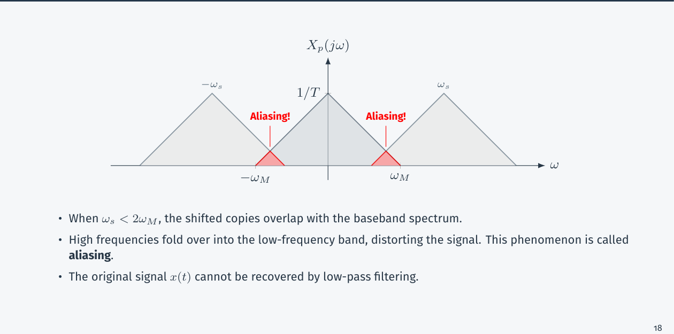
Figure 10.1 — Undersampling: the copies overlap and high frequencies fold into the baseband (Lec 5, sl. 22)
Case | Condition | Result
Oversampling | ω_s > 2ω_M | copies separated by a guard band; recoverable with an LPF
Critical sampling | ω_s = 2ω_M | copies touch; works only in the limit (sinc kernel), impractical
Undersampling | ω_s < 2ω_M | overlap = aliasing: frequency ω appears as ω − kω_s; irreversible

Aliasing and Practical Cures
- Cause: sampling too slowly (or a signal not band-limited): spectral copies overlap, high frequencies masquerade as low ones (e.g. wagon wheels, a 1.8 kHz tone sampled at 2.8 kHz appears at 1 kHz).
- Problems: distortion that cannot be undone; the original signal is lost.
- Cures: an analog anti-aliasing low-pass filter before sampling (cutoff ≤ f_s/2); sample above Nyquist (oversample, which also eases reconstruction filter design); a guard band.
- Why practical signals always alias a little: real signals are time-limited, so their spectra are not exactly band-limited (Lesson 12).

Discrete-Time Sampling (textbook)
For a sequence, X(e^{jω}) = 0 for 2π/9 ≤ |ω| ≤ π, i.e. bandlimited to W = 2π/9. Keeping every M-th sample (rate 1/M of the original) is alias-free iff MW ≤ π ⇒ M ≤ 4.5 ⇒ M = 4 (largest integer): the lowest rate is the original rate/4 (a sample every 4 steps): bandwidth 2π/9 → spread to 8π/9 < π.

Natural Sampling (textbook)
Multiply by a train of rectangular pulses of width τ, period T: p(t) has Fourier coefficients c_k = (τ/T)sinc(kτ/T), so X_s(ω) = Σ c_k X(ω − kω_s): the copies have different heights (sinc-weighted) but the same shape — x is recoverable with an LPF if ω_s > 2ω_M, only scaled by c₀ = τ/T.

Exam Approach
1. Sketch X(jω); mark ω_M; find ω_s and compare with 2ω_M.
2. Draw copies at ±ω_s, ±2ω_s with height 1/T.
3. Aliasing: show the overlap region; cure: anti-aliasing filter / higher f_s.
4. Multiple signals: use the highest frequency present (bandwidth of a product = sum of the bandwidths).

Practice — Lesson 10
(a) Actual — CSE 219 2022-23 Q1(c). (b) Actual — CSE 219 2023-24 Q7(c). (c) Actual — CSE 311 2012-13 Q8(a), 2013-14 Q2(a), 2016-17 Q2(b). (d) Actual — CSE 311 2018-19 Q3(b), 2014-15 Q2(c) [L-3]. (e) Actual — CSE 219 2022-23 Q4(b). (f) Actual — EEE 211 2018-19 Q3(b), EEE 301 2015-16 Q6(b). (g) Natural sampling: EEE 211 2017-18 Q2(c), EEE 301 2014-15 Q6(b).
(a) Band-limited x(t) with ω_s > 2ω_M; analyze how x(t) is uniquely determined by its samples x(nT). (15)
(b) State the Nyquist–Shannon theorem; analyze X_p(jω) when ω_s satisfies/violates it; sketch; why is perfect reconstruction impossible after aliasing? (10)
(c) State and prove the sampling theorem; why in practice is the signal band-limited first and why is the rate above Nyquist? Prove the minimum sampling frequency is 2B. (13–16)
(d) Cause of aliasing, its problems and compensation. (20)
(e) A sequence has X(e^{jω}) = 0 for 2π/9 ≤ |ω| ≤ π. Lowest rate to sample it for perfect reconstruction? (10)
(f) x = sin 1000πt + cos 1200πt: sampling period for no aliasing. z = xy with x, y band-limited to 150 Hz and 350 Hz: maximum T_s; spectra for T_s = 0.5 ms and 2 ms. (10; 12)
(g) Natural sampling with a rectangular pulse train: spectrum; can x be recovered?

✔ Solution
(a) Proof steps 1–3 above; uniqueness: if two band-limited signals had equal samples, their sampled spectra (1/T)ΣX₁(j(ω − kω_s)) and (1/T)ΣX₂(…) would be equal, and with no overlap the central copies X₁ = X₂ ⇒ x₁ = x₂.
(b) Theorem (steps 1–4). Satisfied: copies spaced ω_s apart, guard band ω_s − 2ω_M, LPF recovers x. Violated: overlap, aliasing; the overlapped region is a sum of two or more frequency components, an information loss that no linear filter can invert (in the overlap X_p(jω) cannot tell which copy each part came from).
(c) Proof as above (CSE 311 papers: X_p(f) = f_sΣG(f − nf_s); LPF of bandwidth B recovers G if f_s ≥ 2B — the boundary f_s = 2B is the minimum). (i) A band-limiting filter before sampling removes energy above f_s/2 that would alias. (ii) A rate above Nyquist leaves a guard band so a realizable (non-ideal, finite-slope) reconstruction filter can separate the copies.
(d) Cause: copies of the spectrum overlap because f_s < 2f_M (or the signal has components above f_s/2). Effects: a component at f appears at |f − kf_s| in the baseband (e.g. 1.8 kHz at f_s = 2.8 kHz → 1 kHz), irreversibly distorting the signal. Compensation: anti-aliasing LPF before the sampler, higher sampling rate, guard band; after sampling nothing can be undone.
(e) W = 2π/9; down-sampling by M keeps no aliasing iff MW ≤ π ⇒ M ≤ 4.5 ⇒ M = 4: the sequence can be sampled (decimated) at ¼ of its rate; the lowest rate is 1 sample per 4 (new bandwidth 8π/9 < π).
(f) sin 1000πt: f = 500 Hz; cos 1200πt: 600 Hz ⇒ f_M = 600 Hz ⇒ f_s > 1200 Hz ⇒ T < 1/1200 s = 0.833 ms
z = xy: bandwidth 150 + 350 = 500 Hz ⇒ T_s,max = 1/(2·500) = 1 ms
T_s = 0.5 ms (f_s = 2 kHz): copies every 2 kHz, each ±500 Hz wide ⇒ no overlap (guard 1 kHz)
T_s = 2 ms (f_s = 500 Hz): copies every 500 Hz overlap (width 1000 Hz) ⇒ aliasing, flat sum between copies

(g) Pulse train coefficients c_k = (τ/T)sinc(kτ/T); X_s(ω) = ΣX c_k X(ω − kω_s): copies of the same shape with heights c_k·X; recoverable by an LPF of gain T/τ if ω_s > 2ω_M.

Lesson 11 — Ideal Reconstruction, ZOH and Linear Interpolation
Lec 5 sl. 24–36

1. Ideal Reconstruction (sl. 24–27)
H(jω) = T for |ω| < ω_s/2 (= π/T), 0 otherwise (ω_M < ω_c < ω_s − ω_M)
h(t) = (1/2π)∫_{−π/T}^{π/T} T e^{jωt}dω = sin(πt/T)/(πt/T) = sinc(t/T) (sinc x = sin πx/πx)
x_r(t) = x_p * h = Σ x(nT) sinc((t − nT)/T) (sum of shifted sincs)
h is non-causal (non-zero for t < 0) and decays slowly ⇒ unrealizable ⇒ approximations

2. Zero-Order Hold (sl. 28–31)
Hold each sample for T: h₀(t) = 1 on [0, T] (a staircase; every real DAC). Each sample y(nT) contributes y(nT)h₀(t − nT), which must be 1 from nT to (n + 1)T and 0 elsewhere.
H₀(jω) = ∫₀^T e^{−jωt}dt = (1 − e^{−jωT})/(jω) = T e^{−jωT/2} sinc(ωT/2π)
Magnitude T|sinc(ωT/2π)|: droops inside the passband |ω| < ω_s/2 (about −3.9 dB at ω_s/2) and does not cut out the aliasing copies (non-zero beyond ω_s/2). Phase −ωT/2: a pure delay of T/2 — causal.

3. Linear Interpolation / First-Order Hold (sl. 32–35)
Join adjacent samples by straight lines: the weight of y(nT) must rise 0 → 1 over [(n − 1)T, nT] and fall 1 → 0 over [nT, (n + 1)T] ⇒ h₁ = triangle on [−T, T], peak 1. It equals (1/T)·[h₀(t + T/2) * h₀(t + T/2)].
H₁(jω) = (1/T)[T sinc(ωT/2π)]² = T sinc²(ωT/2π) (real, no delay — the triangle is non-causal; delaying it by T makes it causal)
 | Ideal (sinc) | ZOH (rect) | Linear interp. (triangle)
h(t) | sinc(t/T), ∞ both sides | 1 on [0, T] | triangle on [−T, T]
H(jω) | T rect(|ω| < ω_s/2) | T e^{−jωT/2} sinc(ωT/2π) | T sinc²(ωT/2π)
causal? | no | yes | no (needs one sample ahead; delay T makes it causal)
|H| at ω_s/4 (T = 1) | 1 | 0.90 | 0.81
out-of-band leakage | none | large (sinc sidelobes) | small (sinc² falls faster)
use | theory, offline | real-time DACs | smoother offline/graphics

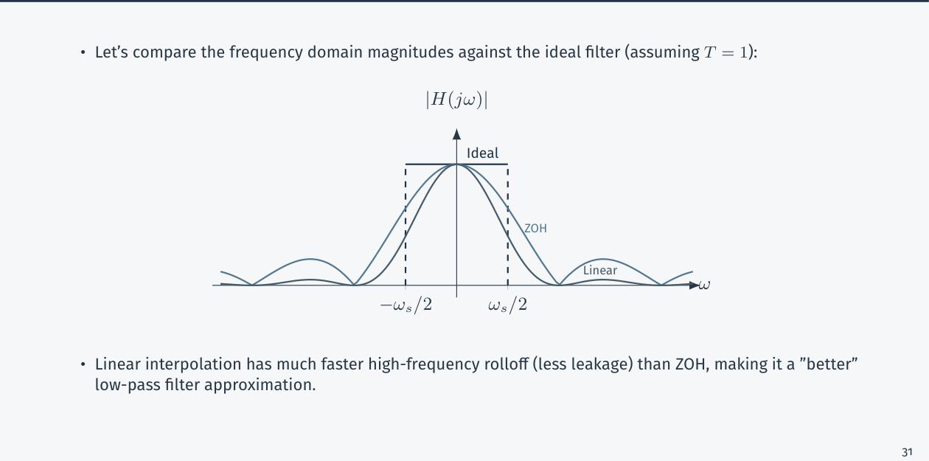
Figure 11.1 — Magnitude responses of ideal, ZOH and linear interpolation (Lec 5, sl. 36)
EXAM-READY ANSWER Real-time DAC (CSE 219 2023-24 Q5(c)(ii)): choose the zero-order hold. It is causal, needs only the current sample (no delay buffer), is a simple hold circuit inside the DAC, and its droop/leakage can be corrected with an analog reconstruction filter. The ideal sinc is non-causal and infinitely long; linear interpolation needs the next sample (one-sample delay buffer), so it is not directly real-time.

Exam Approach
1. Write h(t) for each method and the reason it has that shape (weight of one sample).
2. Derive H(jω) by Fourier integration (rect → sinc), triangle = rect * rect.
3. Compare causality, passband flatness and out-of-band leakage.
4. State a one-line advantage and drawback of each.

Practice — Lesson 11
(a) Actual — CSE 219 2023-24 Q5(c). (b) Actual — CSE 311 2018-19 Q1(a), 2021-22 Q3(b), 2010-11 Q6(c), 2020-21 Q1(b).
(a) An engineer must convert stored samples to an analog signal using an ideal sinc low-pass filter, a ZOH, or linear interpolation; the hardware cannot do non-causal filtering and no delay buffer is allowed. (i) Compare the three impulse responses. (ii) Which should he choose? (5 + 5)
(b) g(t) is band-limited to 50 Hz; samples at 0.01 s: g(0) = 1, all others 0. Find g(t) and G(f) and its characteristics. Same with Nyquist-rate samples zero except g(0) = A. Samples at 2B through an ideal LPF of bandwidth B give an output ∝ f(t). Can the past samples foretell the future?

✔ Solution
(a) (i) Ideal: h = sinc(t/T), two-sided and infinite ⇒ non-causal. ZOH: h₀ = rect on [0, T] ⇒ causal, finite. Linear: h₁ = triangle on [−T, T] ⇒ finite but non-causal. (ii) ZOH (see EXAM-READY ANSWER).
(b) samples g(0.01k) = δ[k]: f_s = 100 Hz = 2 × 50 Hz (Nyquist rate), so g = Σδ[k]sinc((t − 0.01k)/0.01) = sinc(100t)
= sin(100πt)/(100πt); G(f) = 0.01·rect(f/100) (flat 0.01 on |f| < 50 Hz, T = 0.01).
Characteristics: band-limited (|f| ≤ 50 Hz), even, real, non-causal, infinite duration, zeros at t = ±0.01k, energy
E = ∫|G|²df = 0.01²·100 = 0.01; G(f)/T flat = the spectrum of a 'band-limited δ': as B → ∞, g → δ(t), G → 1
— the Dirac delta's flat spectrum is the limiting case (justifies δ ↔ 1).
Samples zero except g(0) = A at Nyquist ⇒ g = A sinc(t/T)·…; same form scaled by A.
Samples at 2B through an LPF (gain T, cutoff B): Σf(nT)δ(t − nT) → f(t) ⇒ output ∝ f(t) (proportionality constant = filter gain × T... equals f when gain T).
'Foretell the future': every future sample of a band-limited signal is determined by the past (the sinc-sum is a linear combination), but only in theory — infinite memory, exact band limit and no noise are needed.

Lesson 12 — Practical Issues; Connection to the DFT
Lec 5 sl. 38–47

Time-limited vs Band-limited (sl. 38)
A signal cannot be both time-limited and strictly band-limited (uncertainty principle). Real signals are finite-duration, so their spectra have infinite tails; the tails always overlap in sampling ⇒ some aliasing is unavoidable. Practical measures: anti-aliasing filter, rate above Nyquist, realizable reconstruction filters (ZOH + analog LPF), quantization noise handled separately.

DTFT and DFT from the Sampled Signal (sl. 39–42)
- X_p(jω) = Σx[n]e^{−jωnT} repeats every ω_s; with ωT → ω this is the DTFT.
- The ideal LPF keeps one ω_s-wide period: x(t) = (1/2π)∫_{−ω_s/2}^{ω_s/2}T X_p(jω)e^{jωt}dω ⇒ inverse DTFT at t = nT.
- The N-point DFT = N uniform samples of one ω_s-wide period: X[k] = X_p(jkω_s/N).

Periodic Signals (sl. 43–47)
x(t) = Σ a_k e^{jkω₀t} ⇒ X(jω) = 2πΣa_kδ(ω − kω₀); sample N times per period: T₀ = NT, ω_s = Nω₀
X_p = (1/T)ΣX(j(ω − rω_s)) = (2π/T)ΣΣ a_k δ(ω − kω₀ − rω_s): every line is copied into every band
Nyquist for periodic x: a_k = 0 for |k| ≥ N/2 (|kω₀| < ω_s/2) ⇒ one clean copy per band
c_k = a_k/T, X[k] = T₀c_k = N a_k; inverse DFT x[n] = (1/N)Σ_{k=0}^{N−1}X[k]e^{j2πkn/N}

Practice — Lesson 12
(a) Actual — CSE 311 2013-14 Q2(b), 2020-21 Q3(a).
(a) What are the practical issues in sampling and reconstruction? Why can practical signals not be fully recovered? How are the problems handled/minimised? (10; 24)

✔ Solution
(a) Practical issues: (1) real signals are time-limited ⇒ not band-limited ⇒ aliasing from the spectral tails; (2) the ideal LPF/sinc interpolator is non-causal and infinite, so reconstruction is approximate (ZOH, linear interpolation, finite-length filters); (3) samplers are not ideal impulses (finite-width pulses, jitter); (4) quantization noise; (5) the signal must be known for all time for exact recovery. Handling: an anti-aliasing LPF before the sampler, sample above Nyquist (guard band), reconstruct with a ZOH followed by an analog low-pass (compensating the sinc droop), use practical band-limits (essential bandwidth), enough bits.

Quick Notes — Sampling
Revision points for Lessons 9–12.

L9 · Sampled spectrum
- x_p = xΣδ(t − nT); X_p = (1/T)ΣX(j(ω − kω_s)); P = (2π/T)Σδ(ω − kω_s).
- Duality: X(jt) ↔ 2πx(−ω); product ↔ (1/2π) convolution.

L10 · Theorem, aliasing
- ω_s > 2ω_M; T < π/ω_M. Overlap = aliasing: f → |f − kf_s|; irreversible.
- Cure: anti-alias LPF, higher rate. Product xy: bandwidths add. Natural sampling: sinc-weighted copies.
- DT: M ≤ π/W (W = 2π/9 ⇒ M = 4).

L11 · Reconstruction
- Ideal: H = T on |ω| < ω_s/2, h = sinc(t/T), x = Σx(nT)sinc((t − nT)/T).
- ZOH: h₀ = rect[0,T], H₀ = Te^{−jωT/2}sinc(ωT/2π). Linear: h₁ = triangle, H₁ = T sinc²(ωT/2π).
- Real-time DAC → ZOH.

L12 · Practice
- Time-limited ⇒ not band-limited ⇒ some aliasing always; X[k] = N a_k.

Key Diagrams to Reproduce
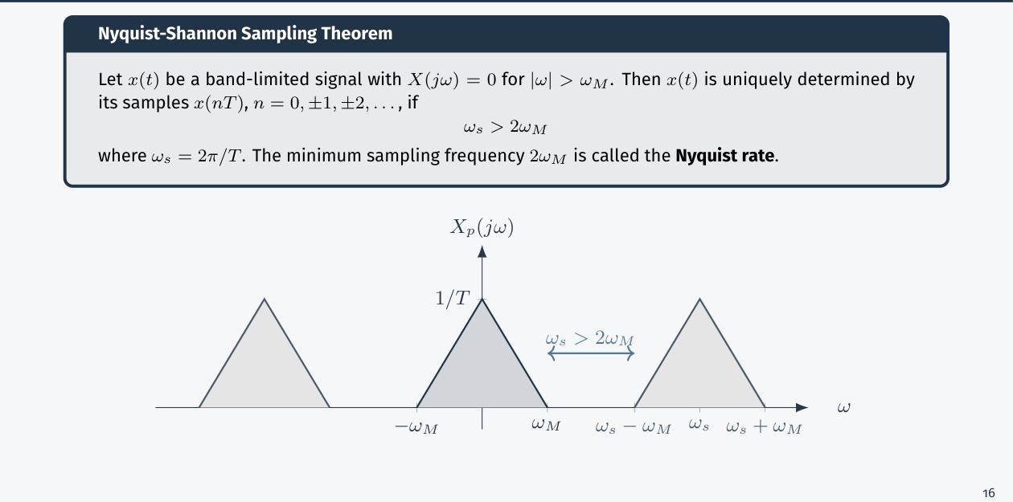
The sampling theorem picture (Lec 5, sl. 20)

